C.V.
Rose Marie Kipreou
Soprano
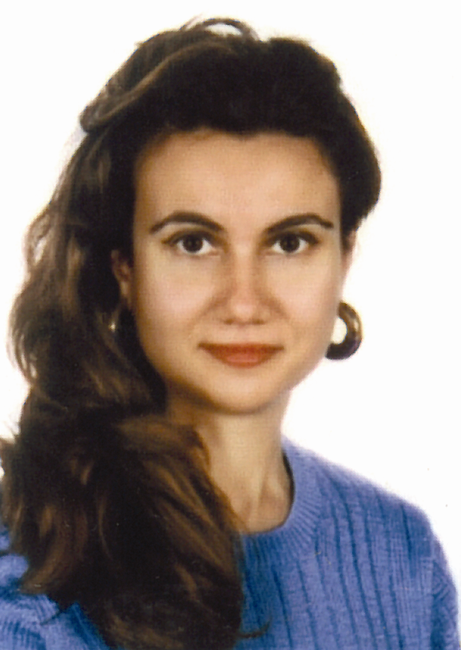

She was born in Athens. She received her piano degree, and was granted with a 1st prize from the National School of Music (prof. M. Mavrikou).
She also received her voice diploma with a 1st prize (class of prof. Kiki Morfoniou) from the Athens Conservatory. She was granted also a degree in French literature from the university of Athens Greece.
Awarded with the Onassis scholarship she continued her voice studies in Berlin under the guidance of famous opera singers and professors like Norma Sharp, Karan Armstrong, the Solorepetitors of the Deutsche Oper Berlin Laurine Richstone and Jeanette Scovotti Soprano of the Metropolitan Opera of New York.
She speaks English, French, German, Italian.

Appearances Abroad
- Berlin, Liederabend, in the Hall of Sciences Academy, with the Michael Bernecker.
- Recital in the International Club of Berlin
- Liederabend in Berlin
- St. Paul Kirche, Baroque Concert, during the “Bach Year”
- Performance of the opera “Wozzeck” by Alf. Berg by the Hans Eisler Academy as “Marie”.
- Bremen Recital
- Alte Oper of Francfort Concert under the conductor Paul Morris. Dortmund, Aachen, Schwartze Villa Berlin, Stutgart, Leipgig Schillerhaus

Recitals
Hamfurg, Heidelberg, Festival Schwetschingen, Karlsruhe, Gelubausa, Ehemalige Synagoge, Franchort and Koln Concerts invited by the Olympic Comittee of Germany Opera of Odessa.

She gives very often concerts in Greece as a solist in Athens and other cities of Greece.

Future Appearances:
Symphonic and Opera works concerning Cyprus and others concerning Ancient Olympia and the Olympic Games in Germany and Peking.
Japan (Kioto – Ozaka)

C.D. “Odyssey” by V. Melitos
“Born of a dream” by G. Vukanos

Rose – Marie Kipreou
Athens: Pindou Str. 69 15669 Papagos
Fax & Tel: 0030-210-6513096, Mob. 0030 693-6513096
Berlin: Lutzowufer 27 10787 Berlin Deutshland
Tel & Fax: 0049-30-25797214, Mob. 0049-177-2893223

